**（1）、ionic基础**

1. 、ionic简介

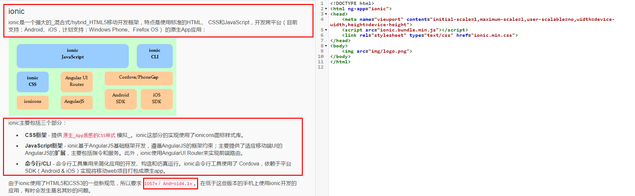

1. 、ionic指令

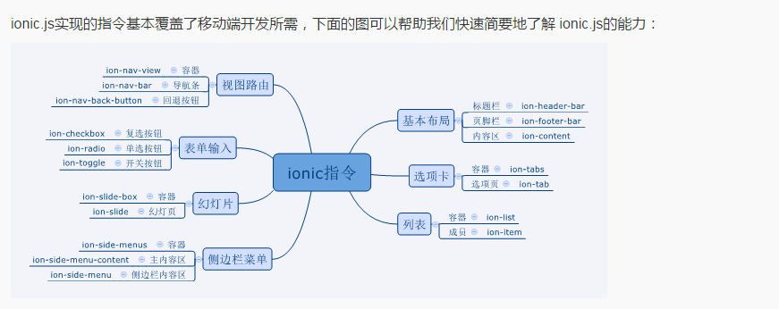

1. 、ionic路由管理

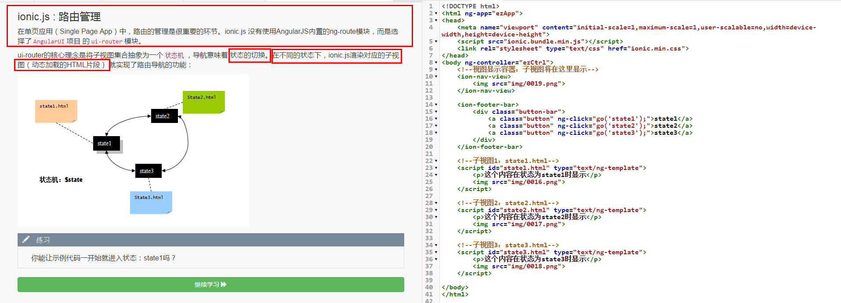

1. 、ionic手势支持

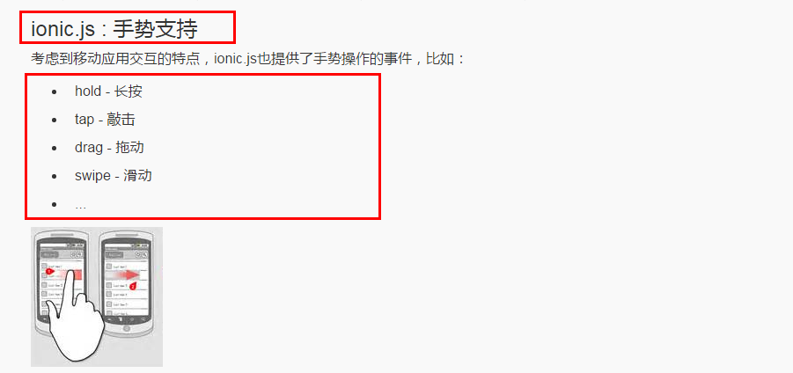

**（2）ionic基本布局**

①、标题栏：ion-header-bar

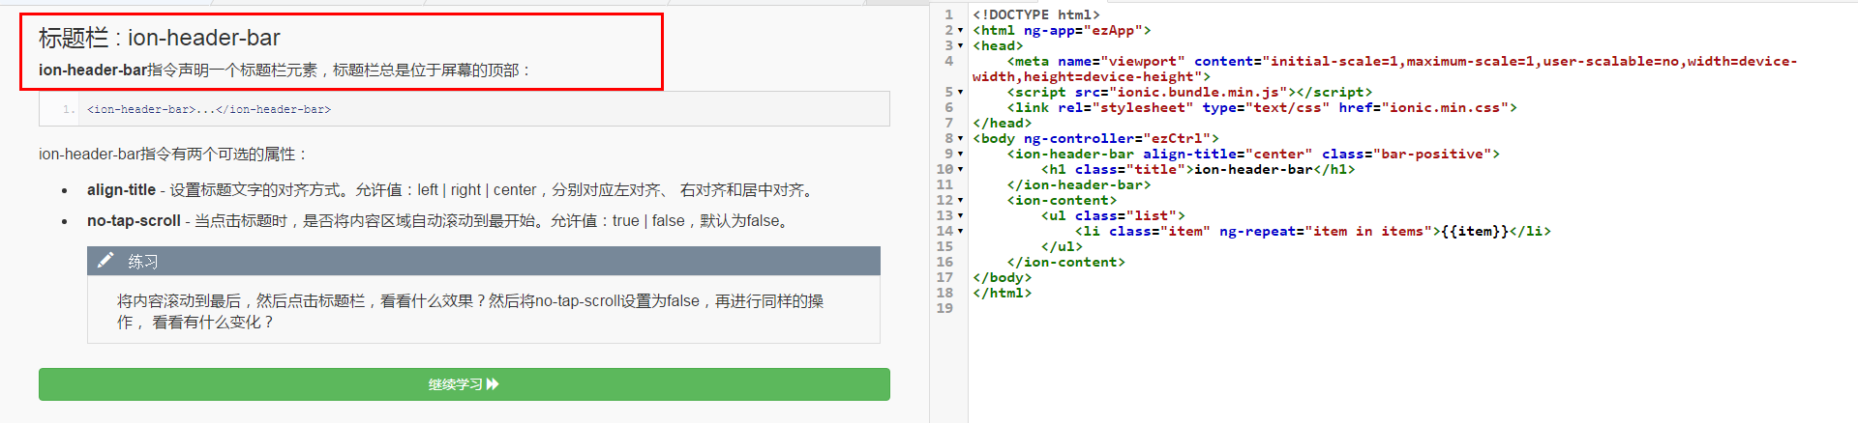

②、页脚栏：ion-footer-bar

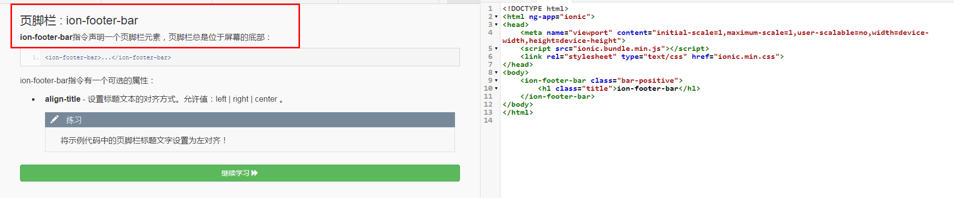

Hearder/footer：样式及内容

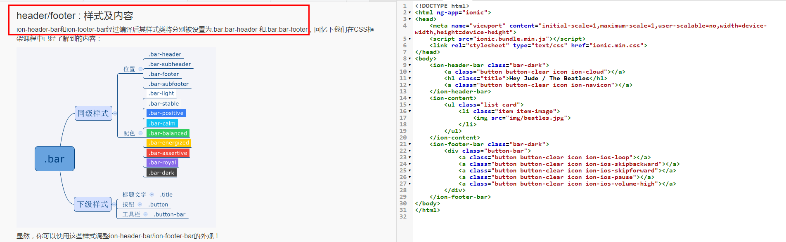

1. 、内容区：ion-content

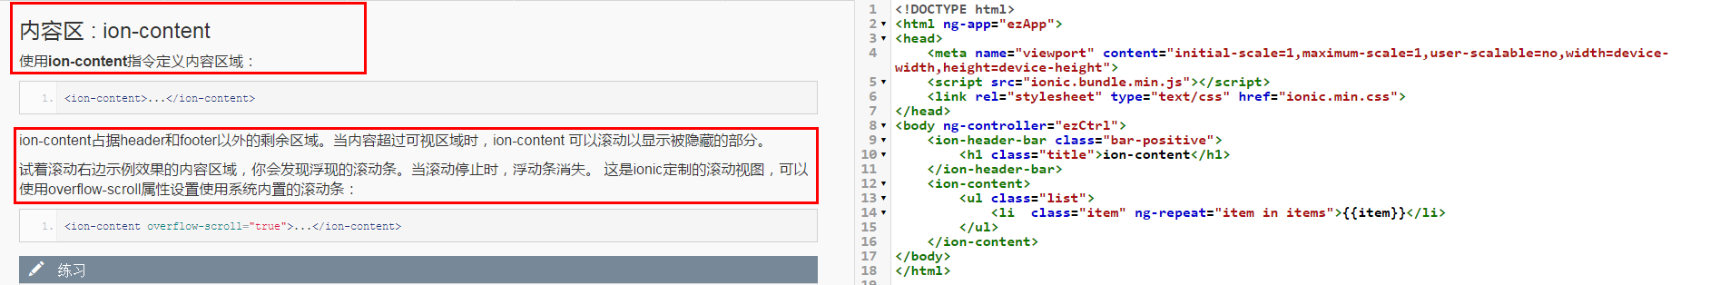

1. 、滚动框：ion-scroll

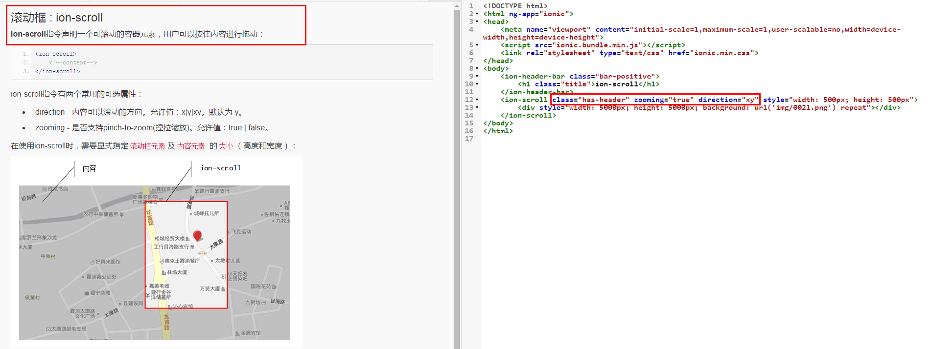

1. 、拉动刷新：ion-refresher

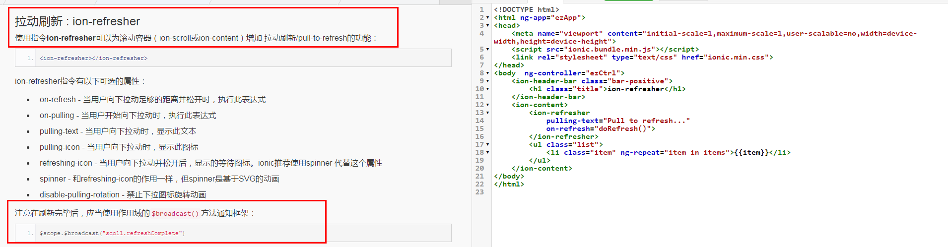

⑥、滚动刷新：ion-infinite-scroll

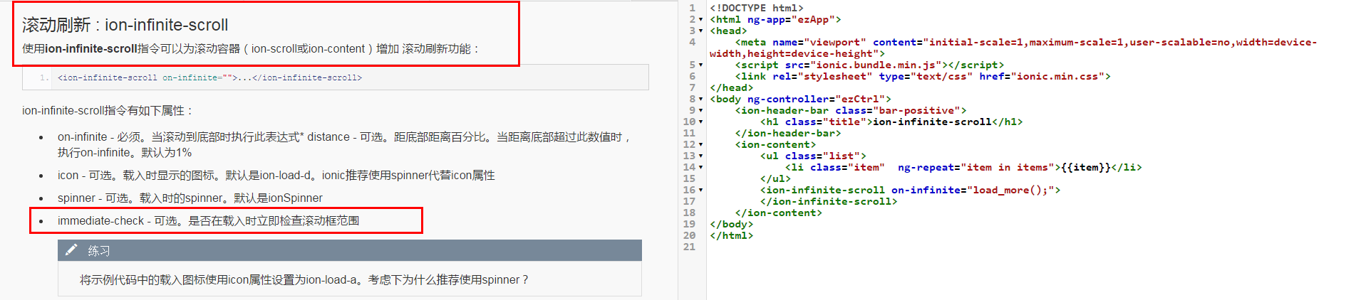

1. 、脚本接口：$ionicScrollDelegate

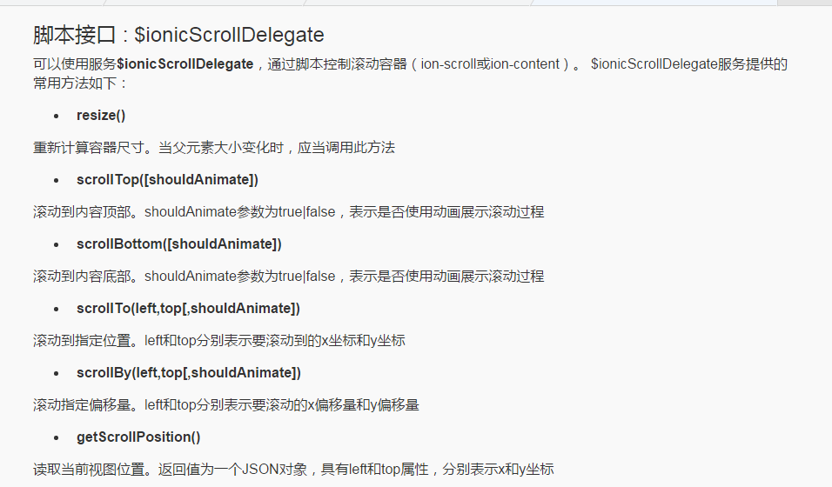

**（3）组件 - 选项卡：ion-tabs**

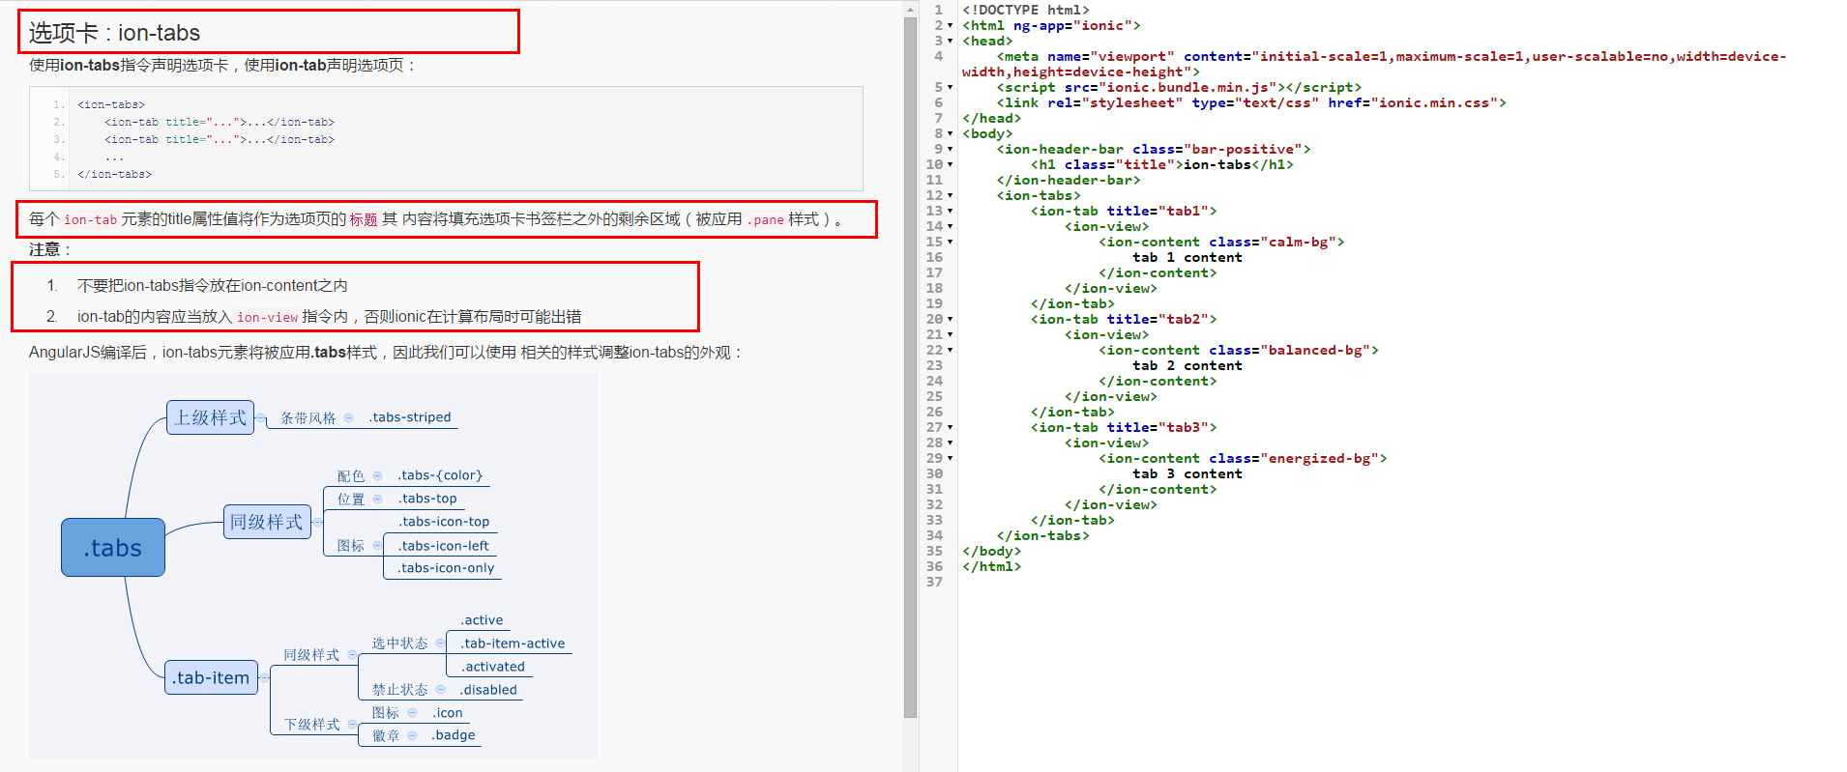

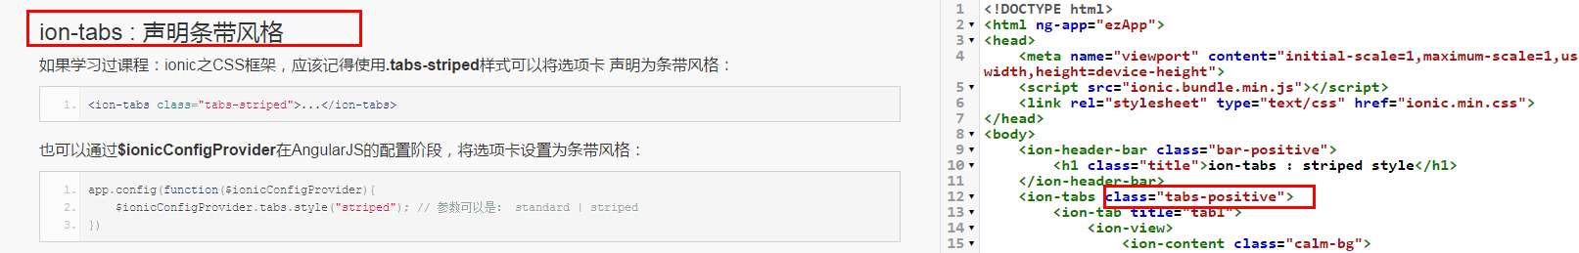

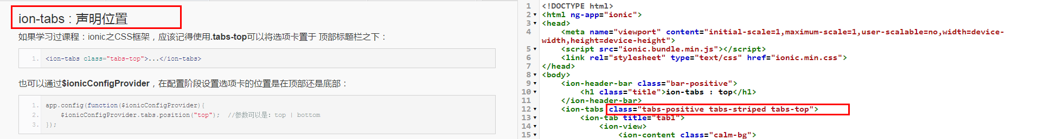

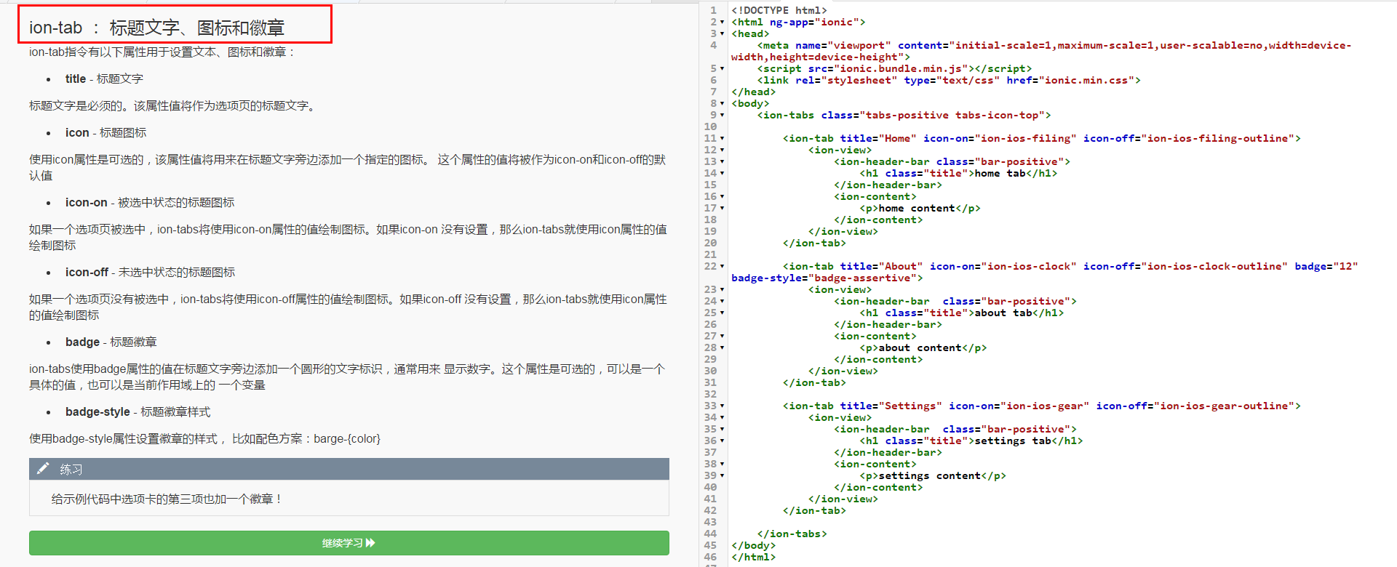

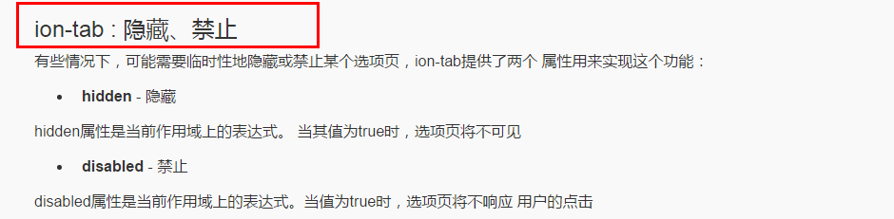

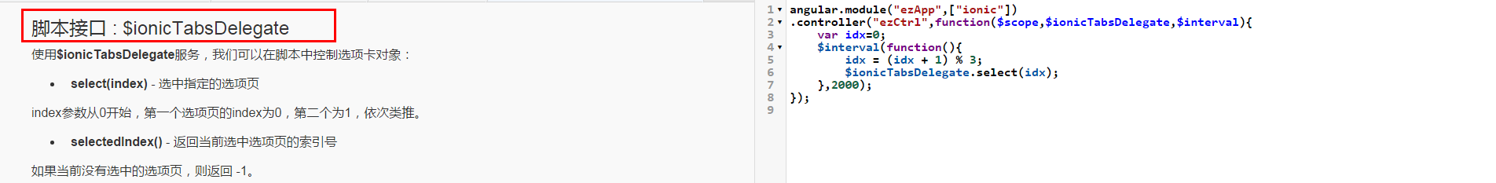

**（4）、组件 - ionic列表**

①、列表：ion-list

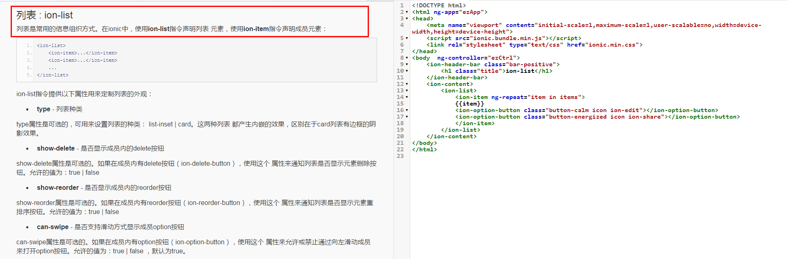

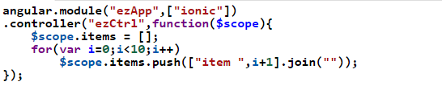

②、ion-item成员按钮

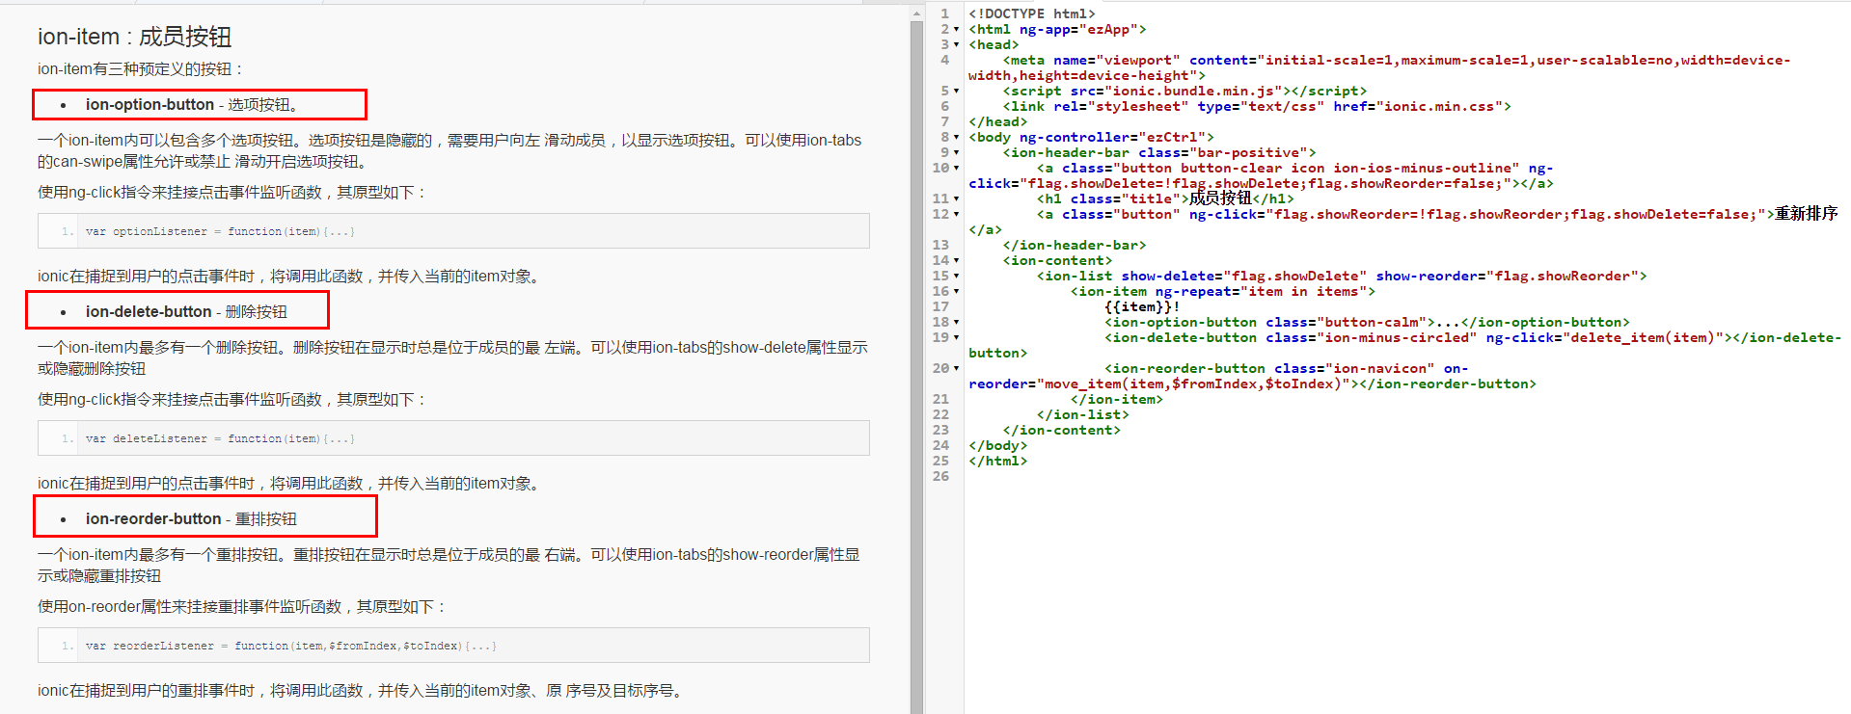

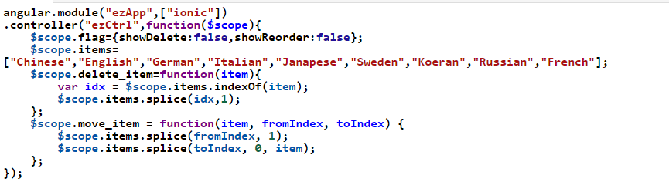

③、collection-repeat : 高性能的ng-repeat

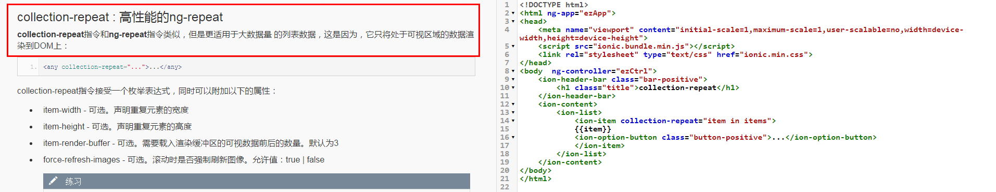

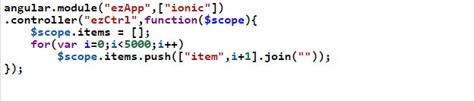

1. 、脚本接口：$ionicListDelegate

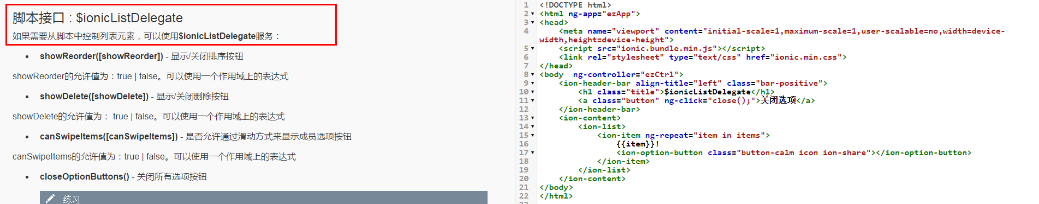

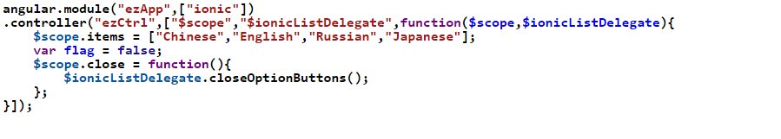

**（5）、组件 - 侧边栏菜单：ion-side-menus**

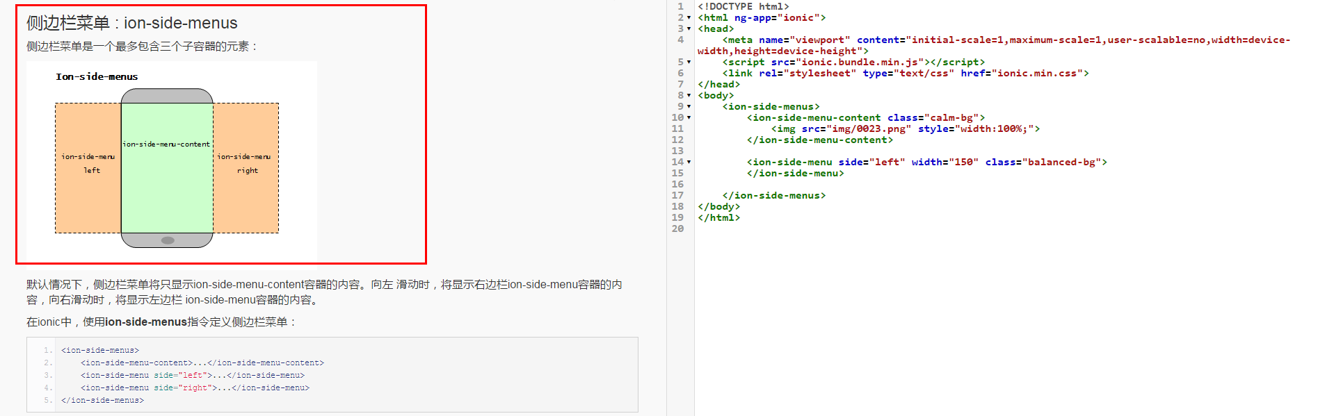

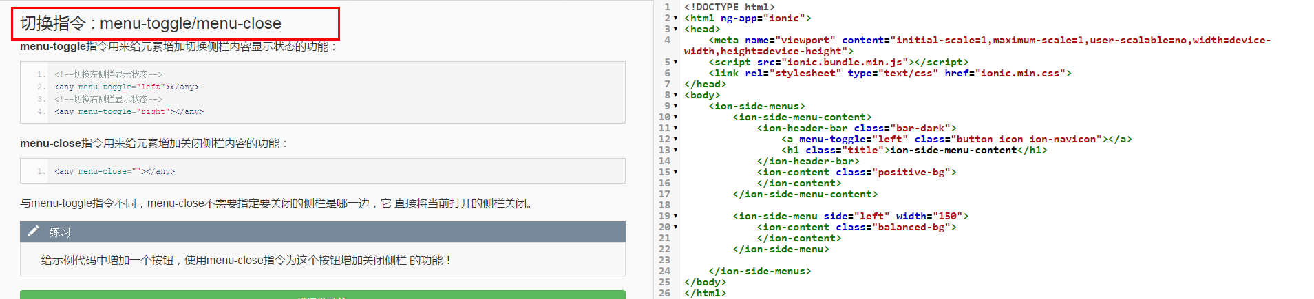

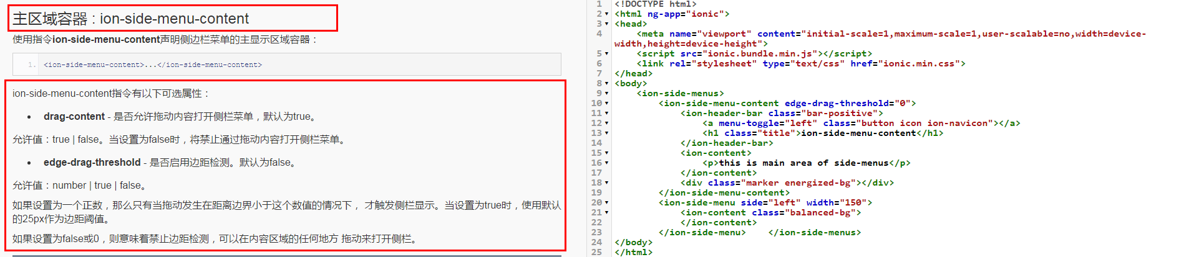

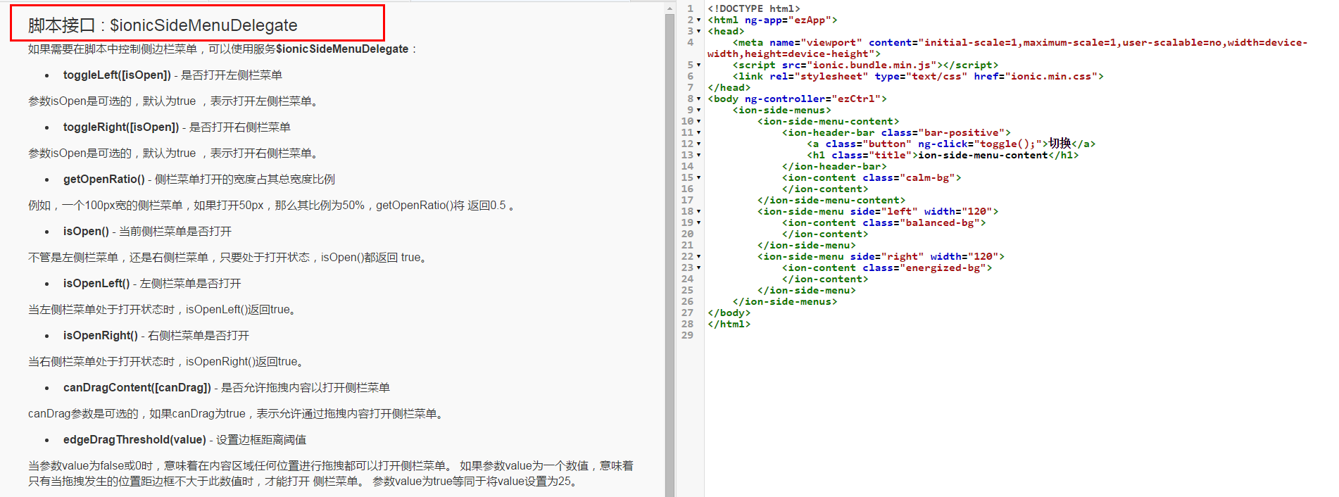

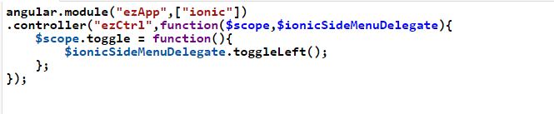

**（6）、组件 - 幻灯片：ion-slide-box**

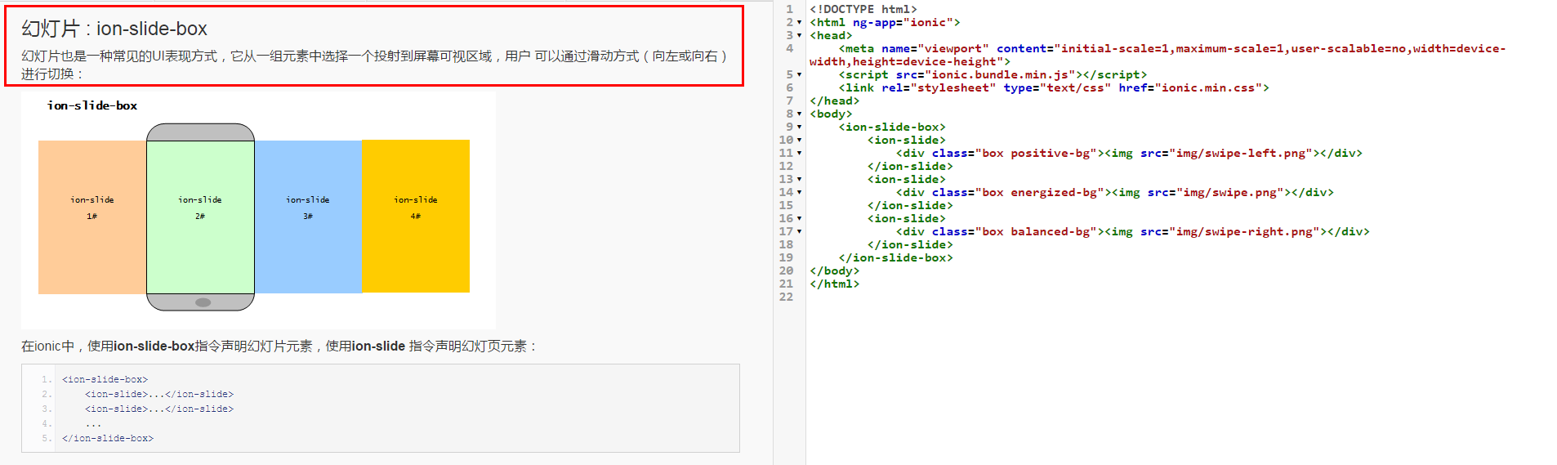

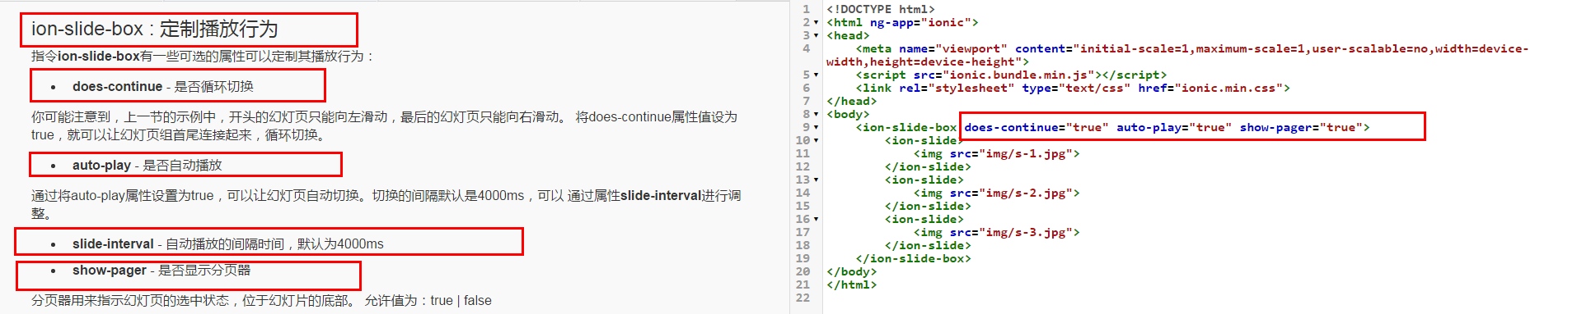

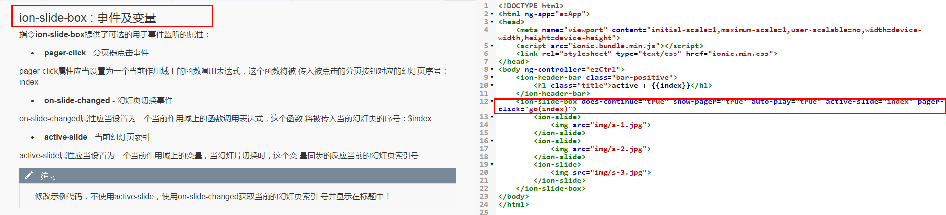

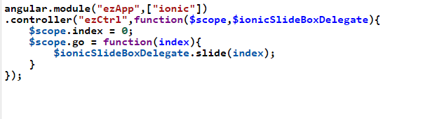

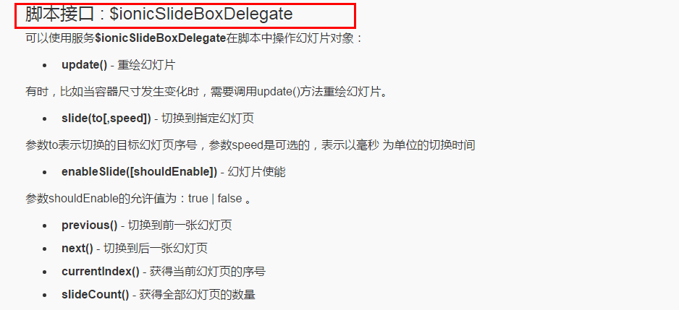

**（7）、组件 - 表单输入**

①、ion-checkbox

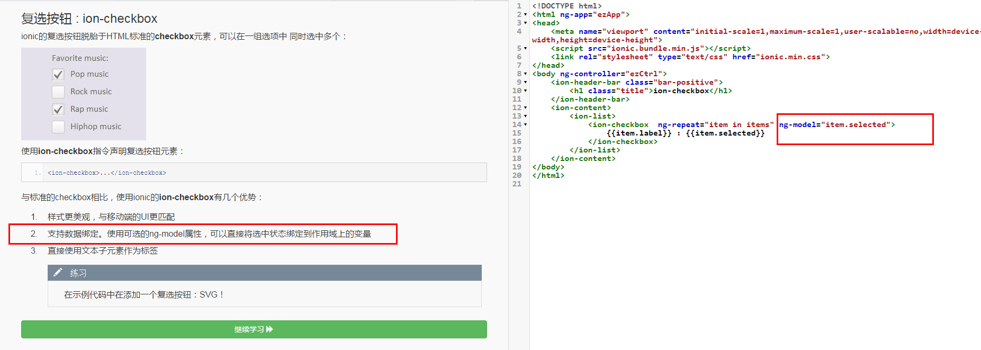

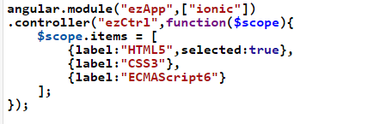

②、ion-radio

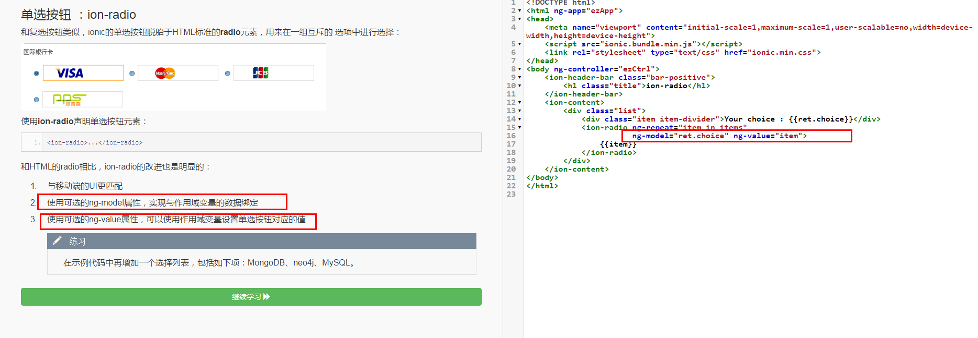

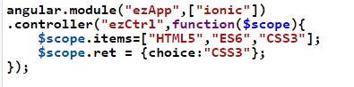

③、ion-toggle

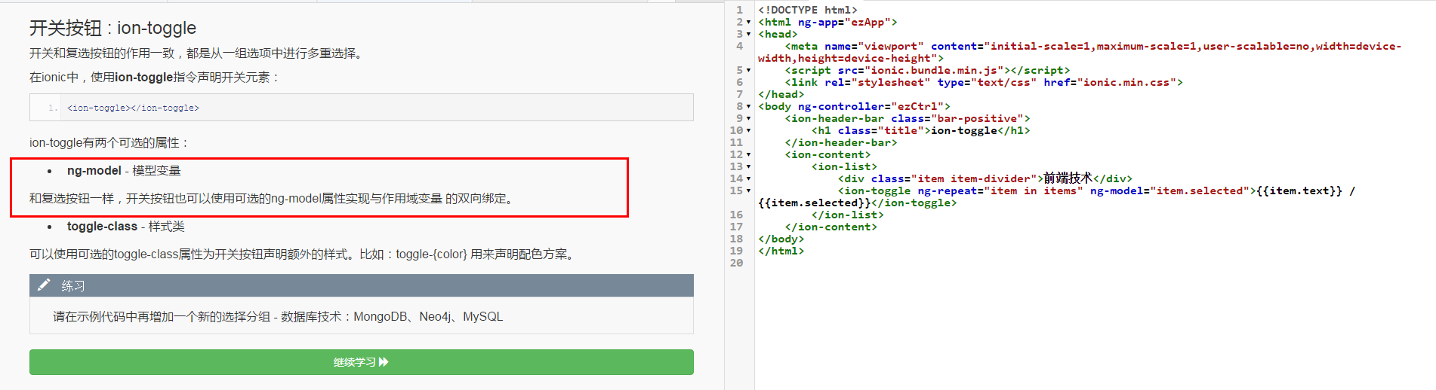

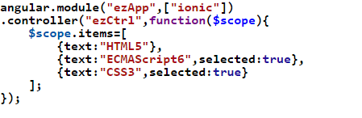

④、ion-spinner

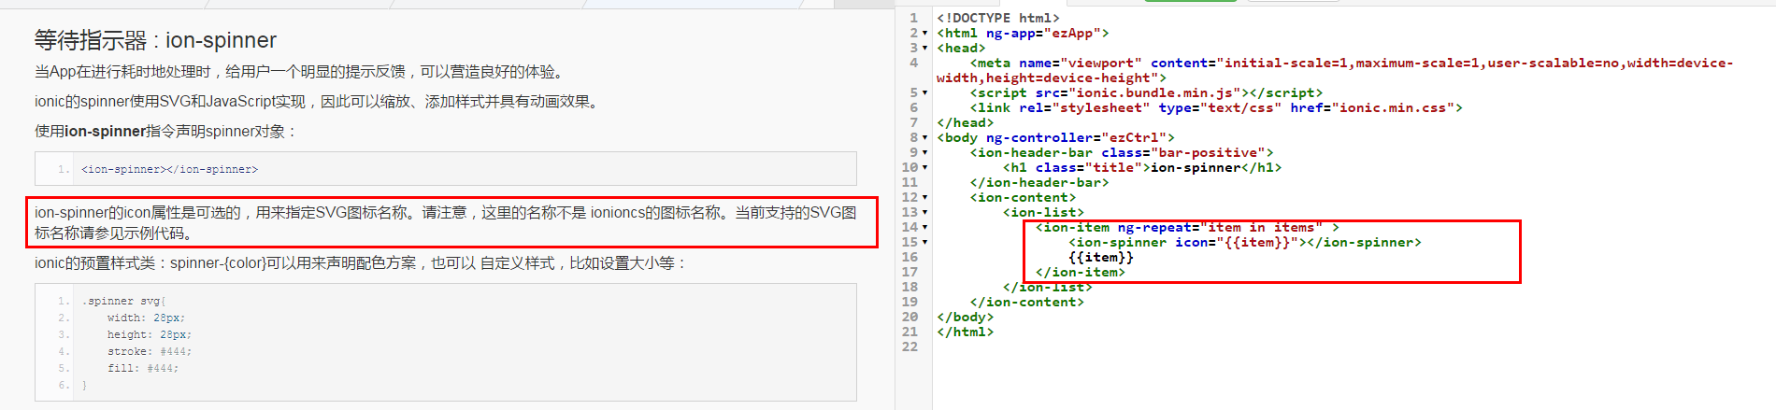

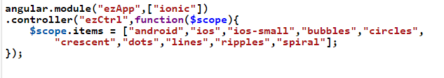

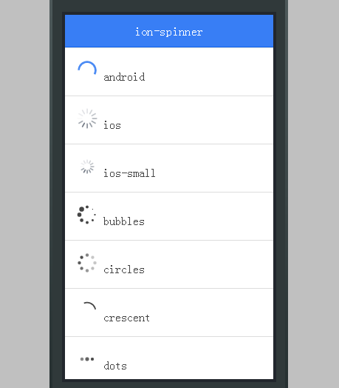

**（8）、动态组件**

①、$ionicModal模态对话框

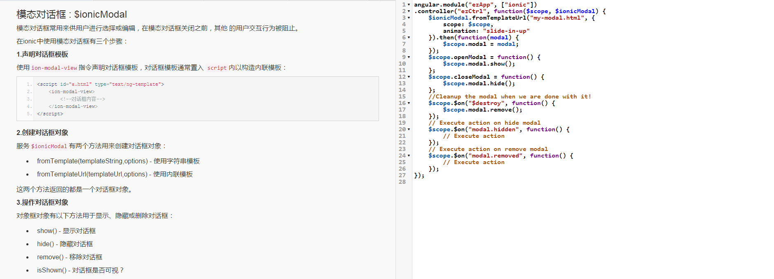

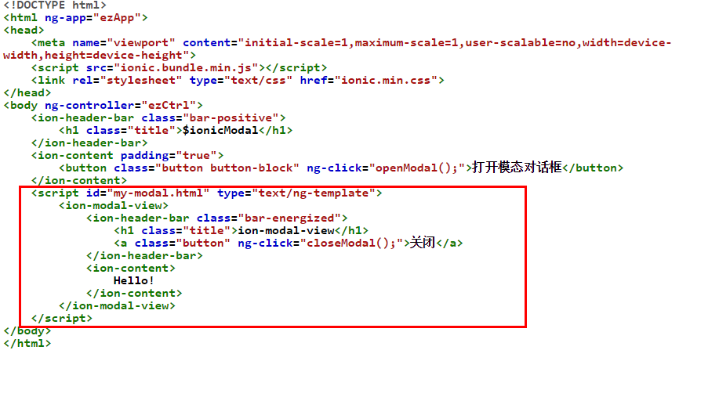

②、$ionicActionSheet上拉菜单

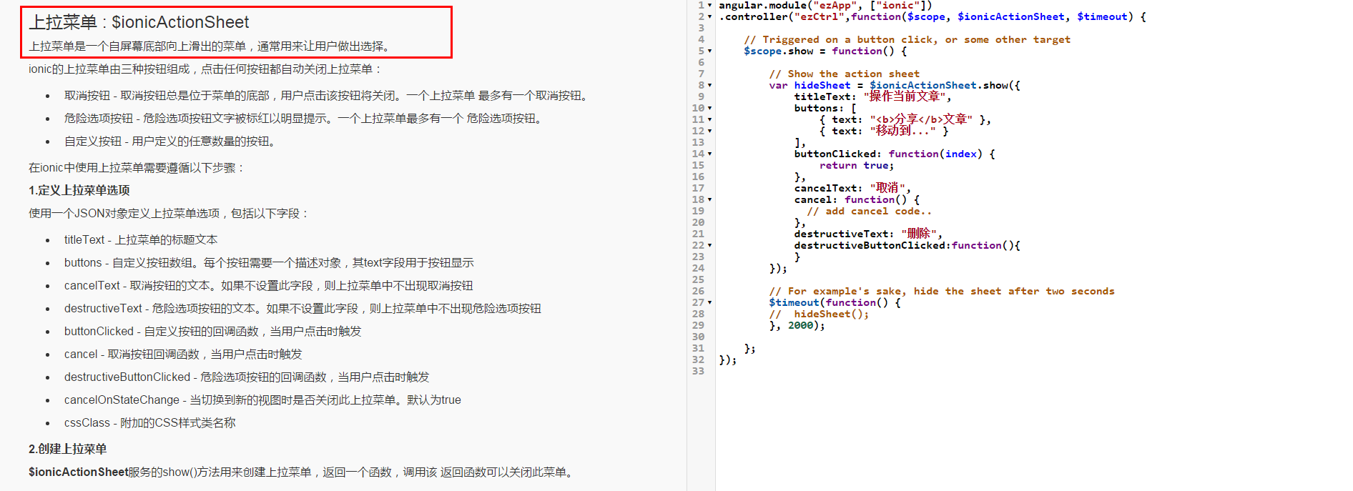

解决安卓手机上上拉菜单样式有误问题：

/* Action Sheets for Android */

.platform-android .action-sheet-backdrop {-webkit-transition: background-color 150ms ease-in-out;transition: background-color 150ms ease-in-out;position: fixed;top: 0;left: 0;z-index: 11;width: 100%;height: 100%;background-color: rgba(0, 0, 0, 0);}

.platform-android .action-sheet-backdrop.active {background-color: rgba(0, 0, 0, 0.4);

.platform-android .action-sheet-wrapper {-webkit-transform: translate3d(0, 100%, 0);transform: translate3d(0, 100%, 0);-webkit-transition: all cubic-bezier(0.36, 0.66, 0.04, 1) 500ms;transition: all cubic-bezier(0.36, 0.66, 0.04, 1) 500ms;position: absolute;bottom: 0;left: 0;right: 0;width: 100%;max-width: 500px;margin: auto;}

.platform-android .action-sheet-up {-webkit-transform: translate3d(0, 0, 0);transform: translate3d(0, 0, 0);}

.platform-android .action-sheet {margin-left: 8px;margin-right: 8px;width: auto;z-index: 11;overflow: hidden;}

.platform-android .action-sheet .button {display: block;padding: 1px;width: 100%;border-radius: 0;border-color: #d1d3d6;background-color: transparent;color: #007aff;font-size: 21px;}

.platform-android .action-sheet .button:hover {color: #007aff;}

.platform-android .action-sheet .button.destructive {color: #ff3b30;}

.platform-android .action-sheet .button.destructive:hover {color: #ff3b30;}

.platform-android .action-sheet .button.active, .platform-android .action-sheet .button.activated {box-shadow: none;border-color: #d1d3d6;color: #007aff;background: #e4e5e7;}

.platform-android .action-sheet-has-icons .icon {position: absolute;left: 16px;}

.platform-android .action-sheet-title {padding: 16px;color: #8f8f8f;text-align: center;font-size: 13px;}

.platform-android .action-sheet-group {margin-bottom: 8px;border-radius: 4px;background-color: #fff;overflow: hidden;}

.platform-android .action-sheet-group .button {border-width: 1px 0px 0px 0px;}

.platform-android .action-sheet-group .button:first-child:last-child {border-width: 0;}

.platform-android .action-sheet-options {background: #f1f2f3;}

.platform-android .action-sheet-cancel .button {font-weight: 500;}

.platform-android .action-sheet-open {pointer-events: none;}

.platform-android .action-sheet-open.modal-open .modal {pointer-events: none;}

.platform-android .action-sheet-open .action-sheet-backdrop {pointer-events: auto;}

.platform-android .action-sheet .action-sheet-title, .platform-android .action-sheet .button {text-align: center;}

.platform-android .action-sheet-cancel {display: block;}

③、$ionicPopup弹出框

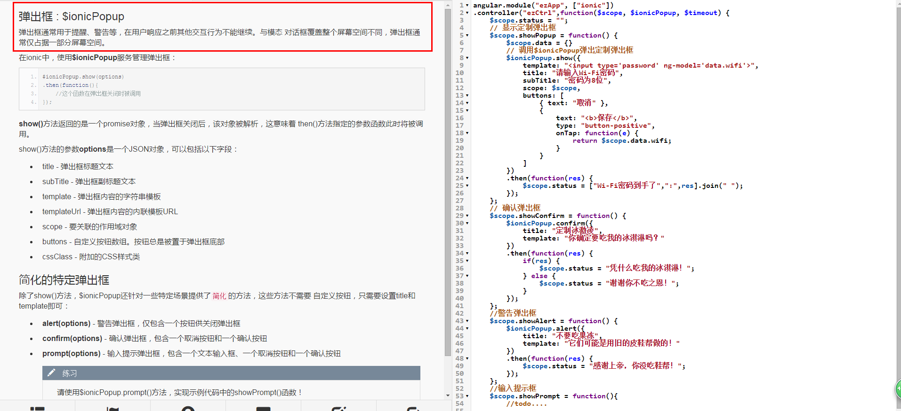

④、$ionicPopover浮动框

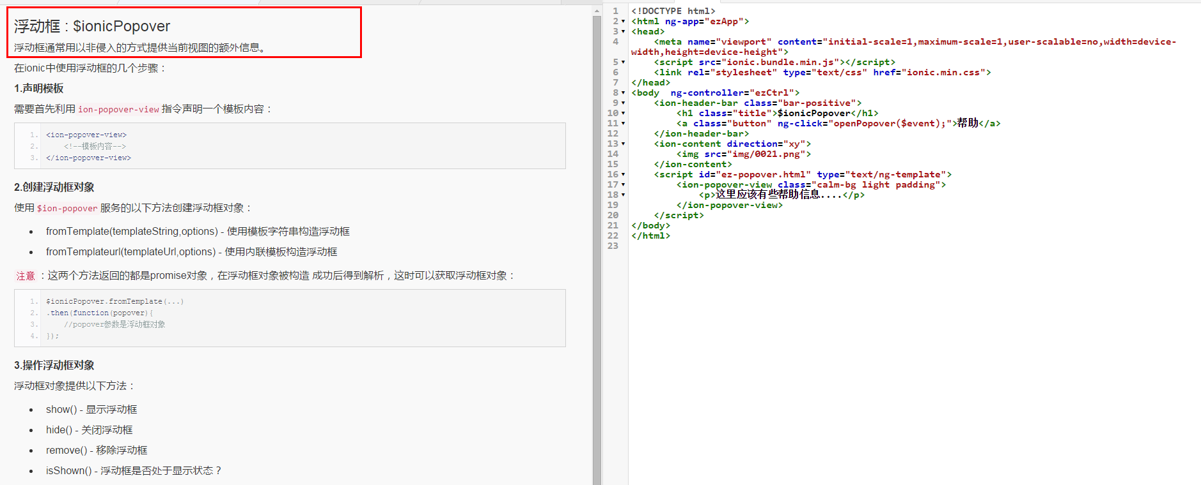

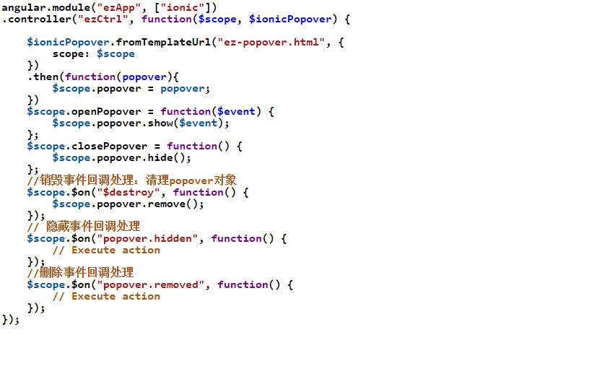

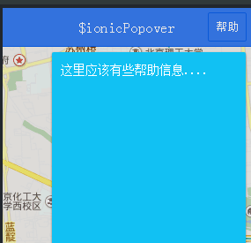

1. 、$ionicLoading载入指示器

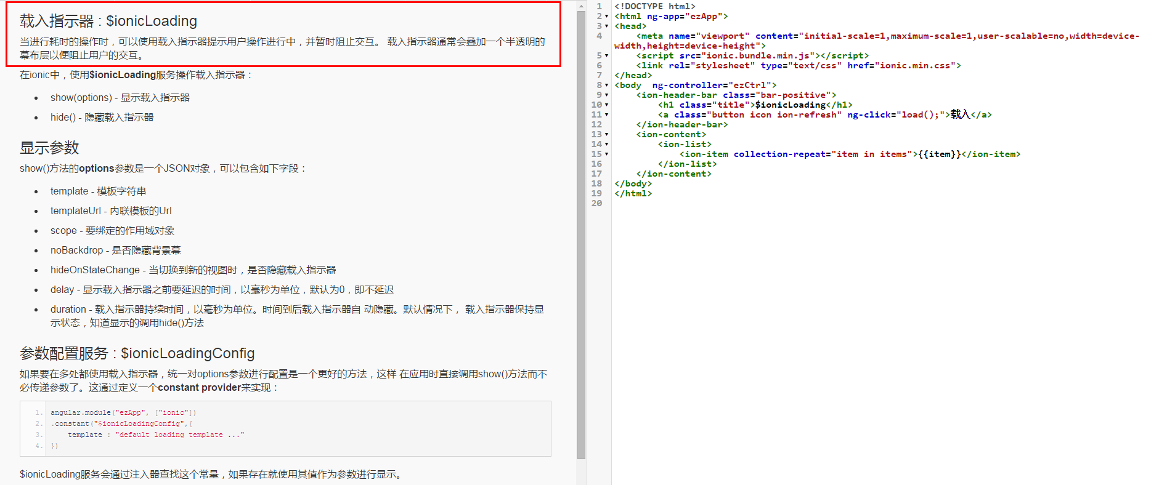

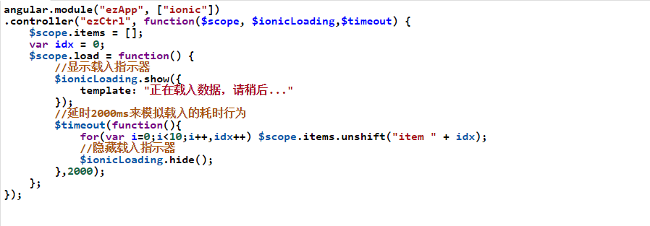

⑥、$ionicBackdrop背景幕

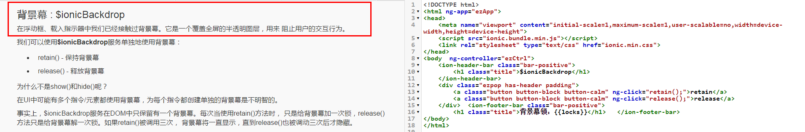

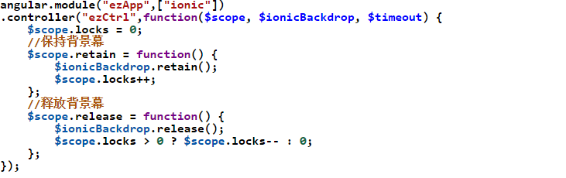

**（9）、视图导航**

①、内联模板：script

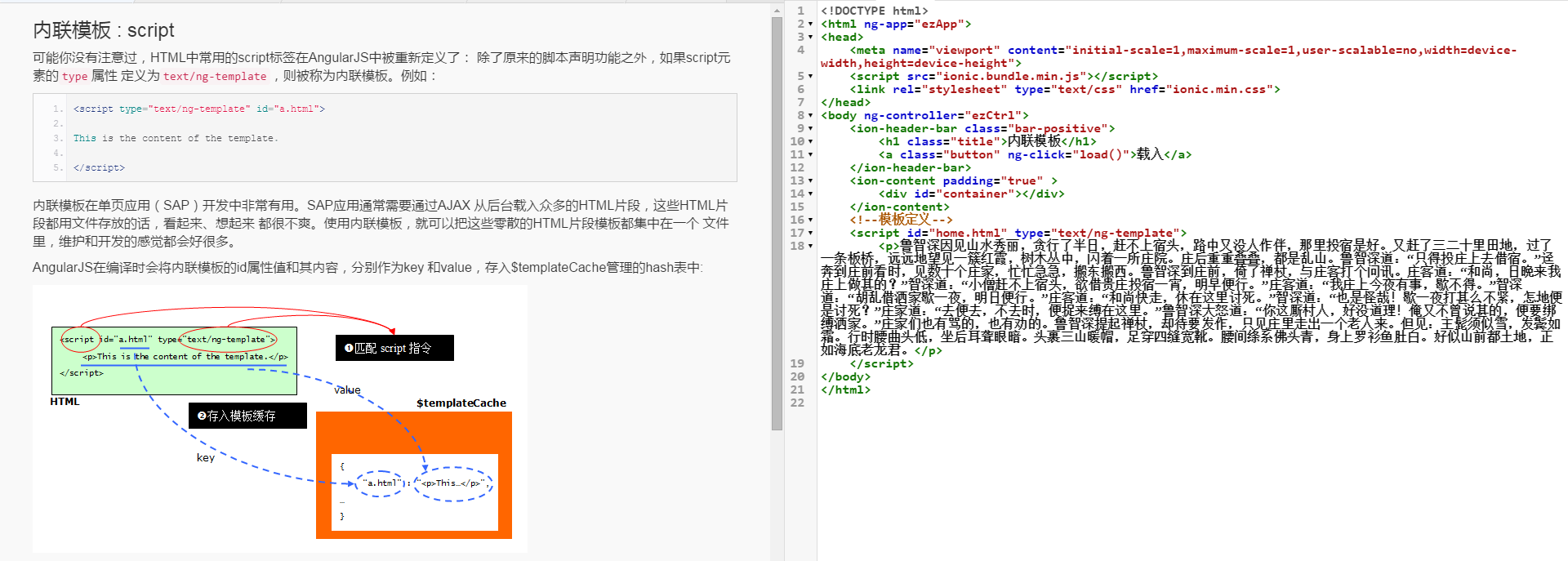 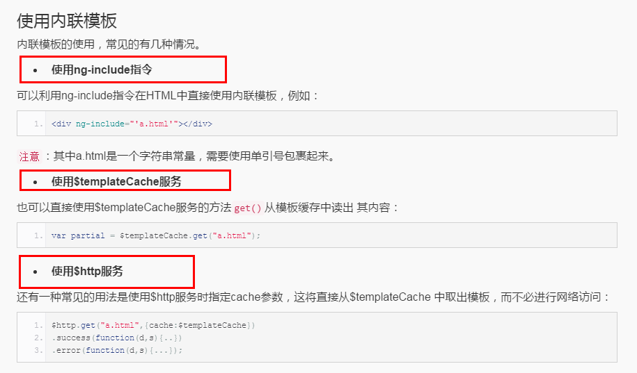

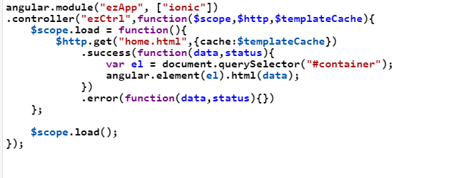

②、路由机制：状态机

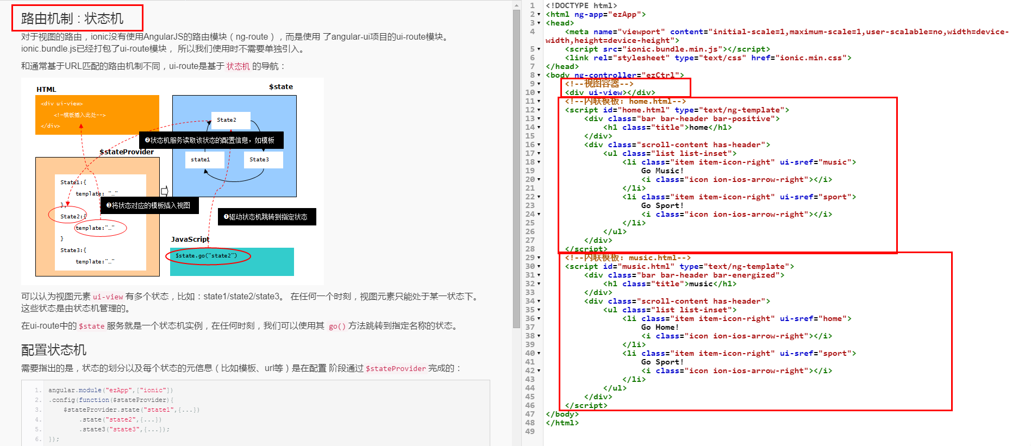

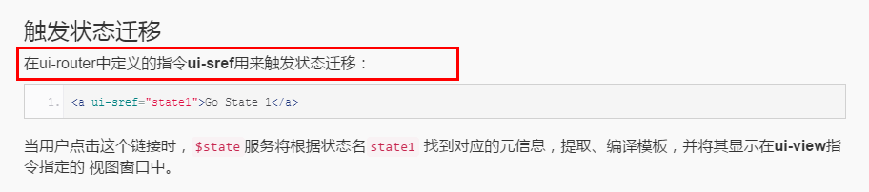

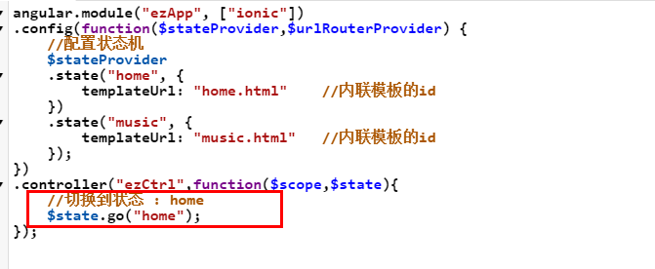

③、导航视图：ion-nav-view

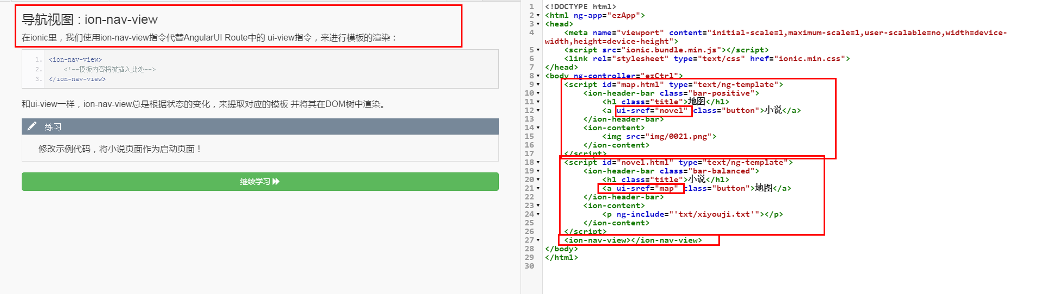

（）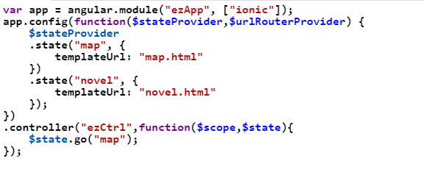

④、模板视图：ion-view

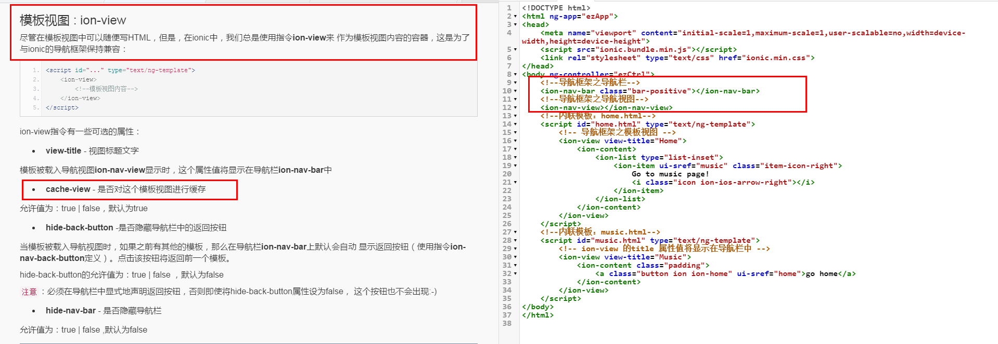

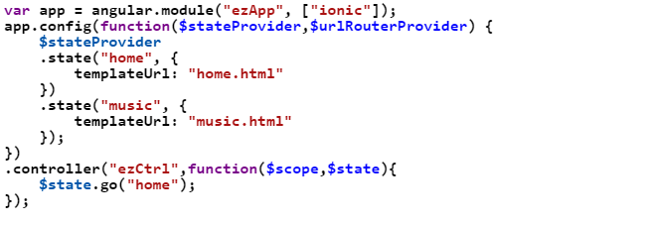

1. 、导航栏：ion-nav-bar

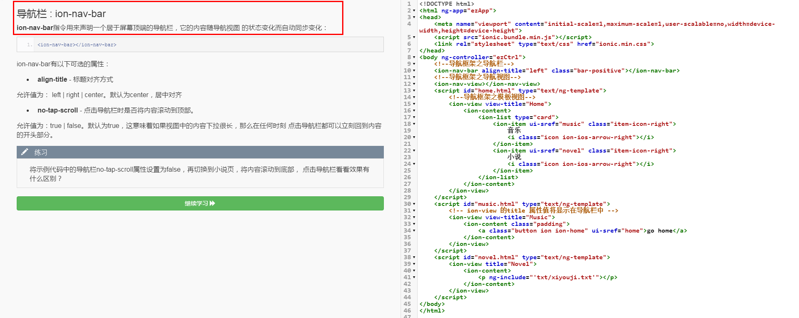

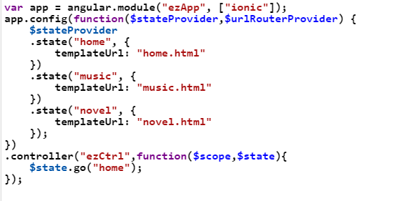

⑥、回退按钮：ion-nav-back-button

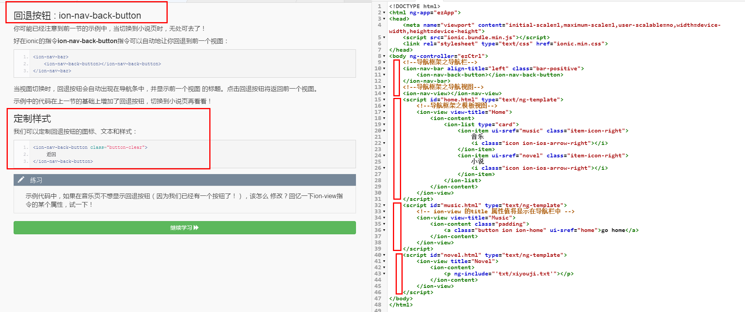

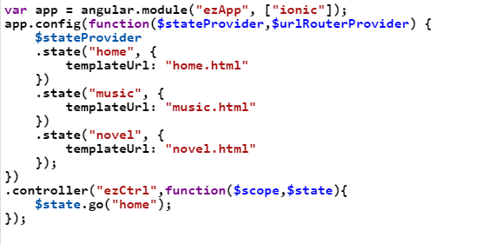

⑦、视图特定按钮：ionic-nav-buttons

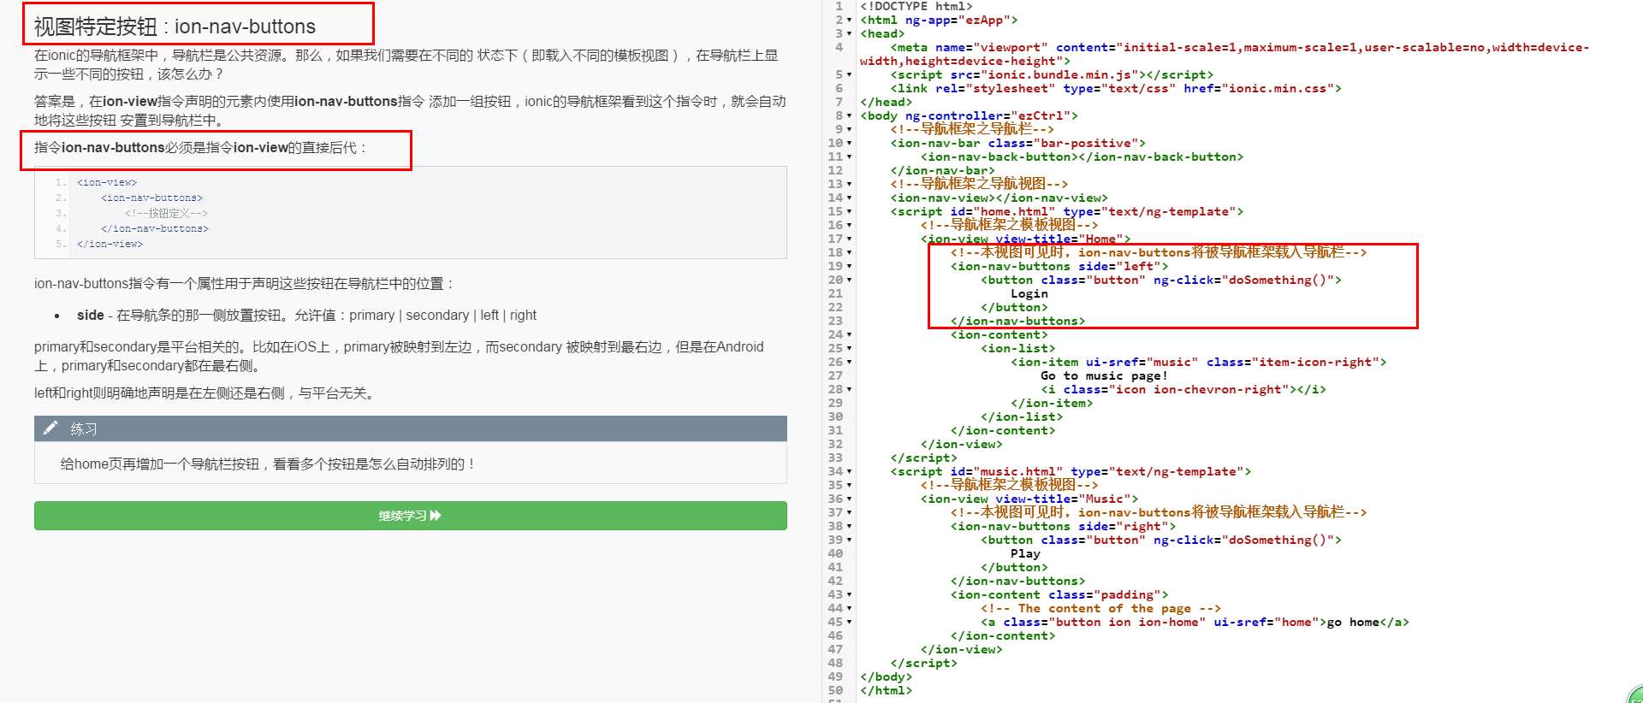

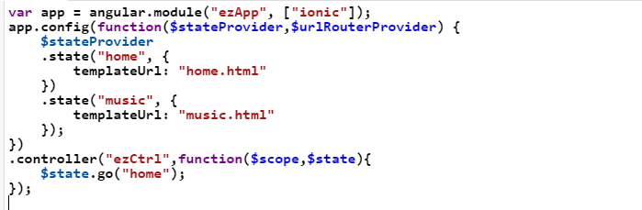

⑧、定制标题内容：ion-nav-title

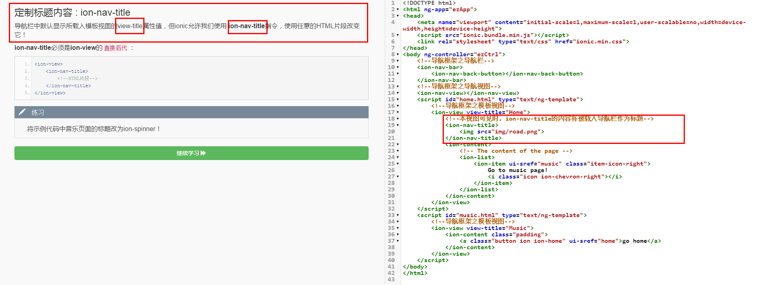

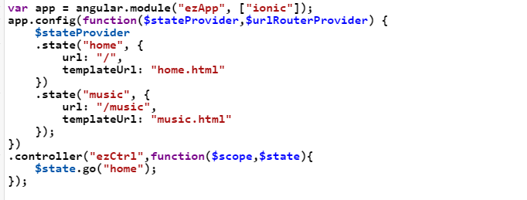

⑨、定制视图切换方式：nav-transition

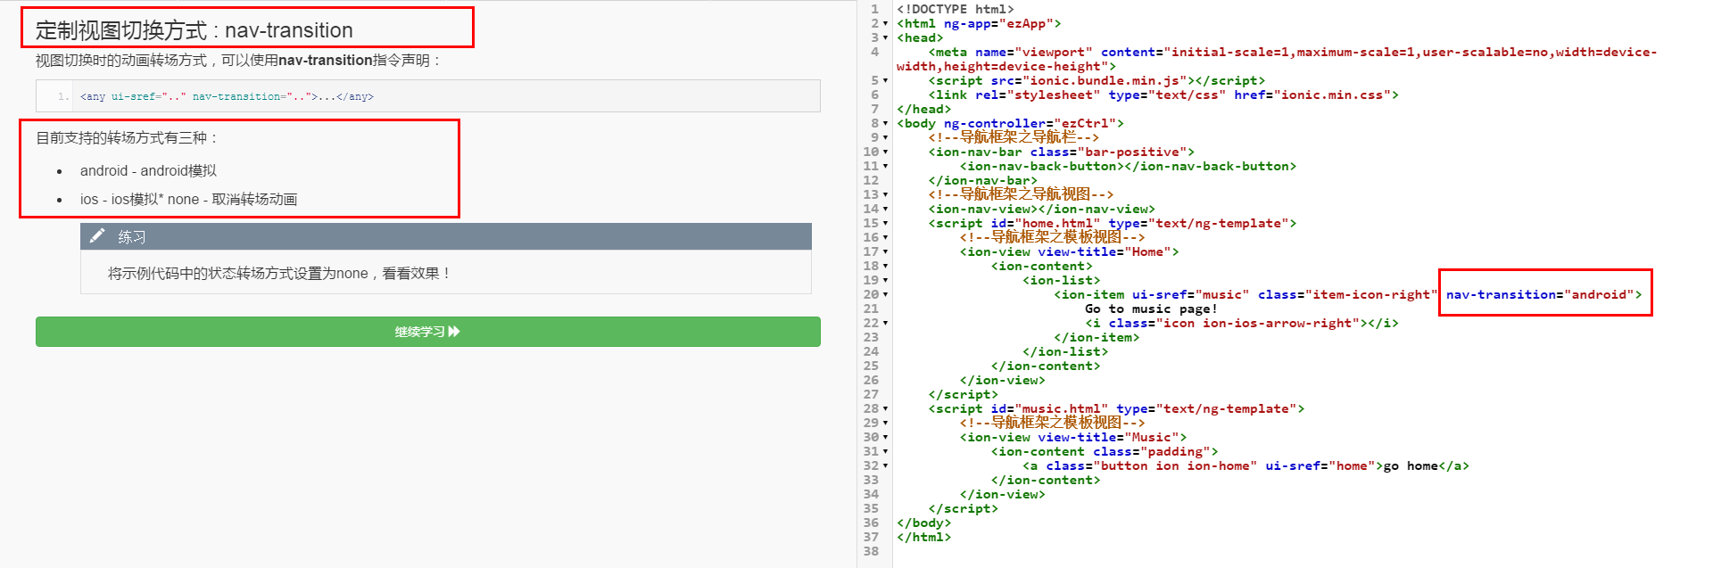

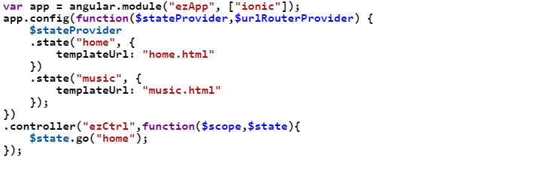

10、定制视图切换方向：nav-direction

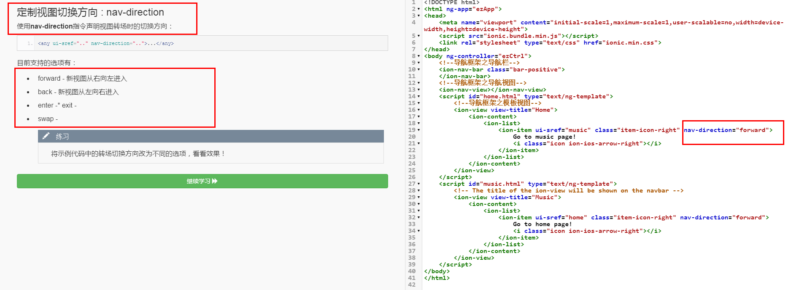

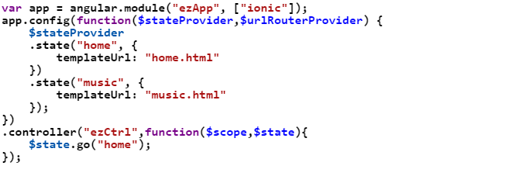

11、导航栏脚本接口：$ionicNavBarDelegate

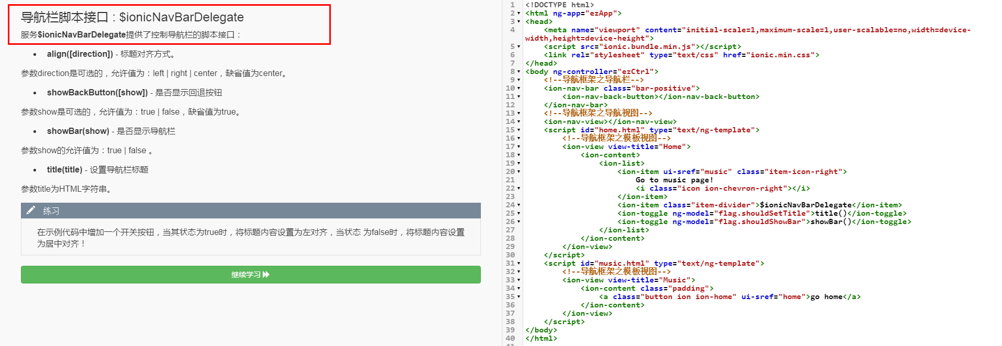

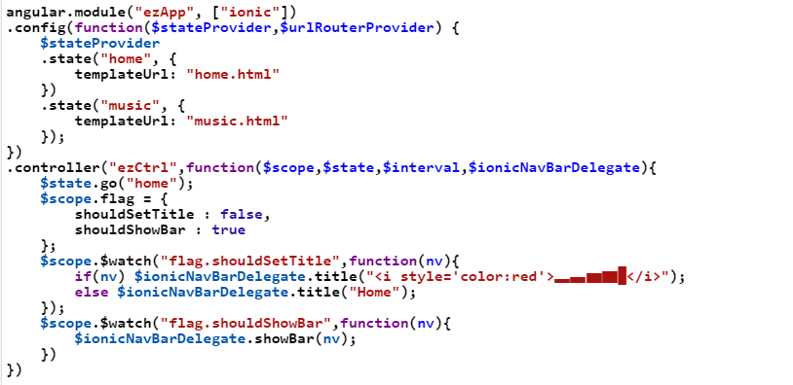

12、访问历史：$ionicHistory

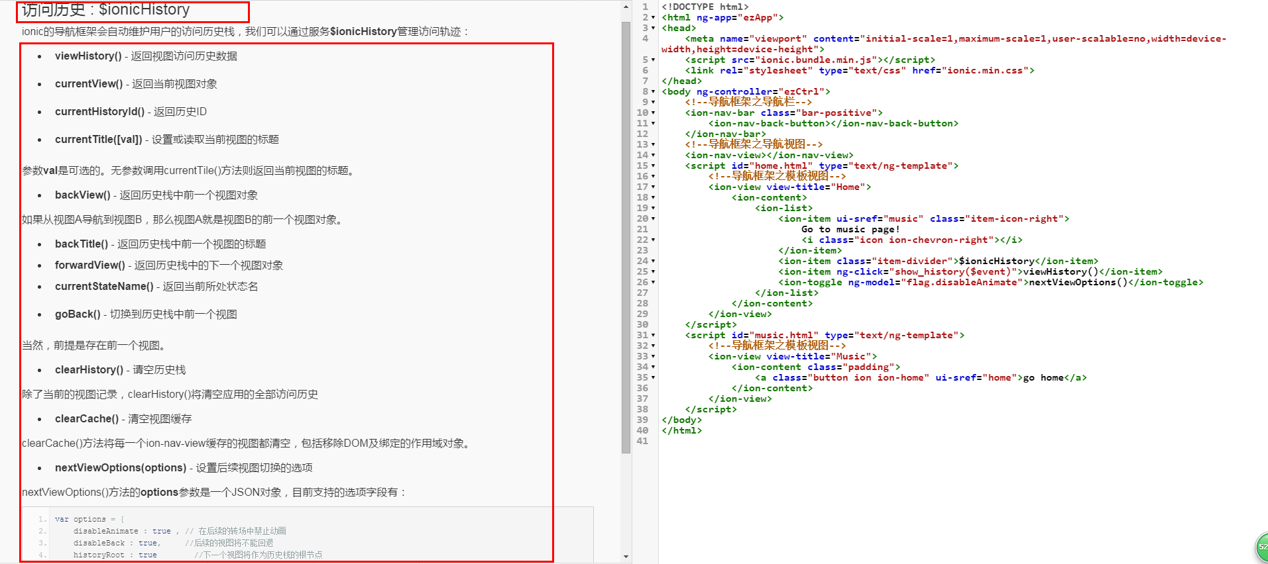

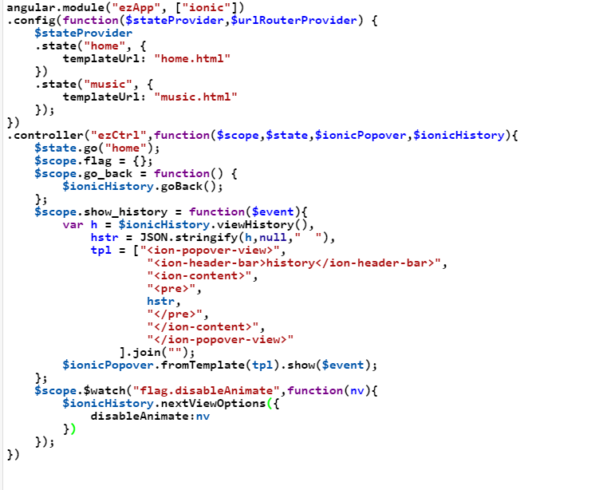

**（10）、ionic手势事件**

①、长按：on-hold

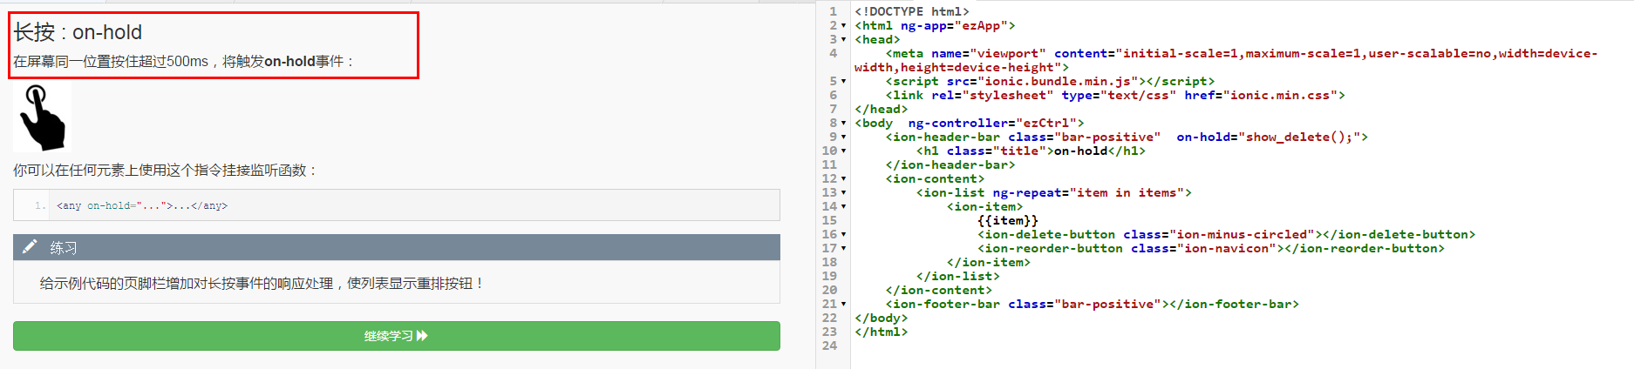

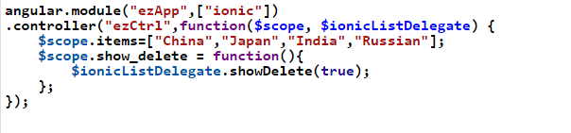

②、敲击：on-tap

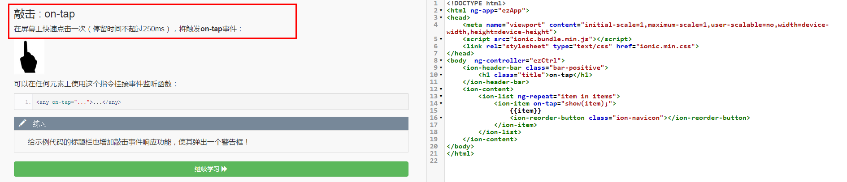

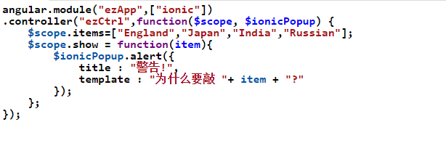

③、双击：on-double-tap

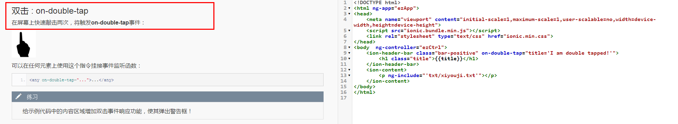

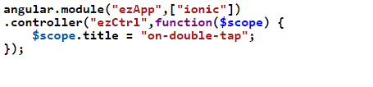

④、按下/松开 on-touch/on-release

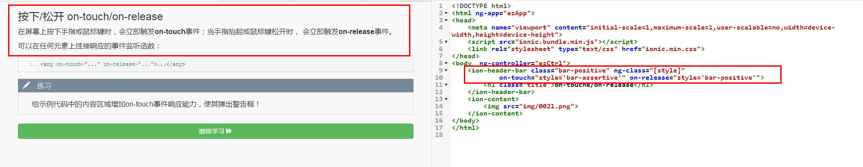

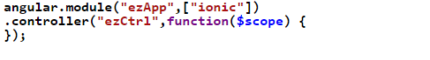

⑤、拖拽：on-drag

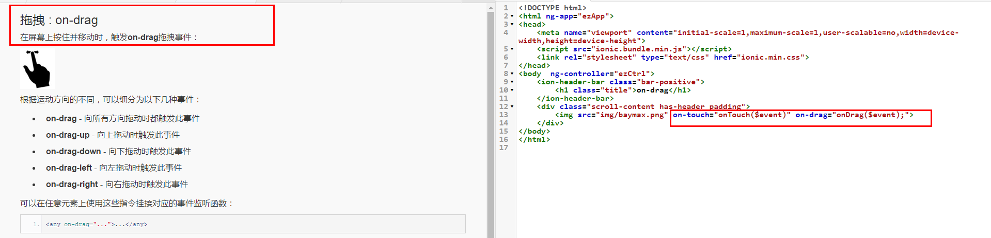

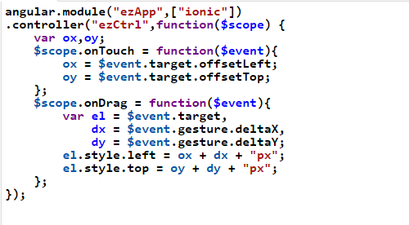

⑥、划动：on-swipe

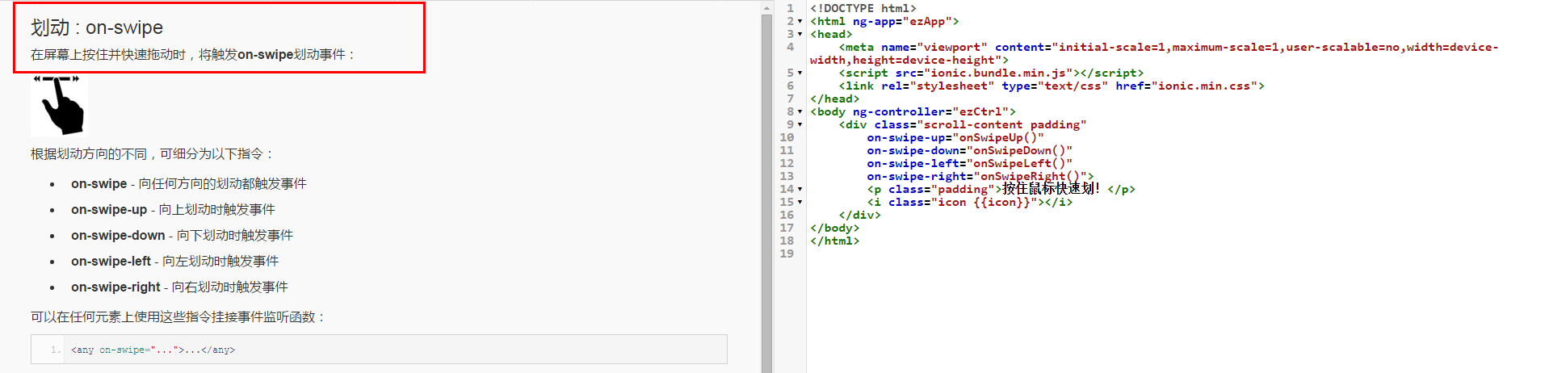

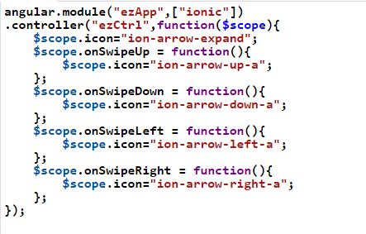

⑦、脚本接口：$ionicGesture

